Hatton Gallery
Art Activities

Kurt Schwitters' Merz Barn Wall

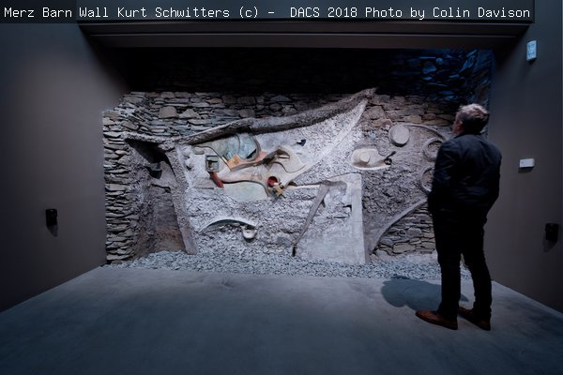
This work is hugely important to the Hatton. Read the story of its acquisition here: https://hattongallery.org.uk/collections/kurt-schwitters-merz-barn-wall

Artist information:
Born in Hanover in 1887, Kurt Schwitters was a German artist involved with the Dada movement. Directly affected by the depressed state of Germany following World War I, he began to collect garbage from the streets and incorporate it directly into his art. The resulting collages were characterised by their thoughtful and surprising arrangements and their incorporation of a wide range of media. He produced journals and musical works in addition to his wide range of painting and sculpture.
Schwitters fled his homeland as the Nazis advanced. He travelled first to Norway and then on by the last boat to Scotland as the Germans came ever closer. On arrival in Britain, he was interned as an enemy alien, first at Warth Mills (Bury, Lancashire) and then for 18 months on the Isle of Man. When he was finally released, he made an income by creating portraits but continued to make much more experimental and personal work for himself. He was finally granted British citizenship on 7 January 1948 but died the following day.
Watch this 5minute video on Schwitters here: https://youtu.be/y_9X9LpqDBs

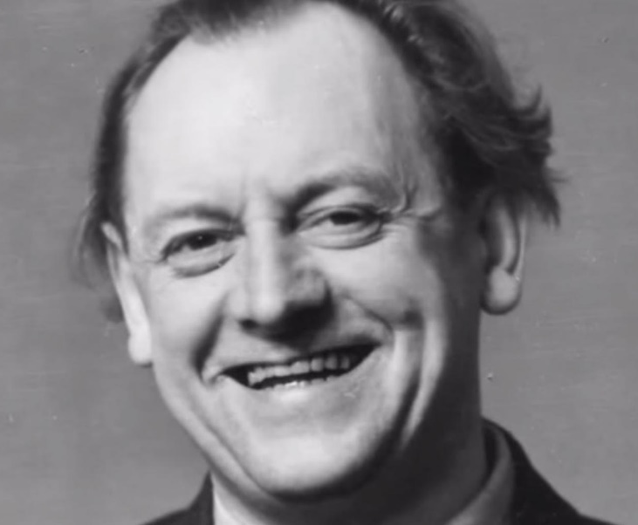
Key stage: 4/5
Length: 6-8 session project
Resources required:
- Found objects collected from local home/ area. A theme could be set by the teacher or selected by students: natural; urban/bedroom/bathroom refuse; or according to a topic: time of day; seasons; memories etc.
Kurt Schwitters photographed by his son Ernst, 1944.
- Containers for casting/curating: pizza box, plastic, tinfoil or cardboard food container
- Quick dry plaster
Learning Objectives:
- To think about how life experiences shape art and how art can help explore an individual or group to cope with adverse experiences
- To learn from, share and empathise through discussions on both making and meaning
- To develop an understanding of the Dada style and ideas of protest art and develop this into own 2D and 3D responses
Success Criteria:
- A range of responses and development of ideas and learning through discussion/dialogue. Sketchbook work and final outcomes.
Other curriculum Links:
- History: World War 1 and 2.
- Geography: Human geography: journeys, problems of migration, conflict and the increasing problem of rubbish, recycling and re-use. Physical geography: land-forms, shapes and textures
- English: Novels and memoirs based on this era:
- Anthony Doerr ‘All the light we cannot see’
- Heather Morris ‘The Tattooist of Auschwitz’
- Elie Wiesel ‘Night’
Key vocabulary: composition, one-point perspective, collage, illusionism, utilitarianism, irrationality, transcendence, found materials, Dada, protest art

Starter Activity:
- Explore the ‘Merz Wall’. Look carefully at and discuss the use of colour, composition, texture and how meaning is shaped or developed through the addition of found elements.
- Discuss Schwitters’ experience of alienation: initially by a German government that sought to publicly ridicule his work as ‘Degenerate’ and then by a British government that imprisoned him as an ‘Enemy Alien’. How would these experiences make you feel? Discuss with a peer or in groups.

Context
Schwitters was interested in challenging traditional modes of artistic representation and production. In 1919, he announced his own, one-man art movement that he called ‘Merz’. Its aim was to combine all forms of creative endeavour and blur traditional boundaries. He produced prose, poetry, typography, painting, sculpture, collage, assemblage and installation.
He was convinced that the act of taking broken fragments and unifying them into a whole demonstrated art's potential to remake and reimagine a fractured world. Additionally, it enabled him to reject conventional illusionism, the rendering of objects as they appear, something he associated with trickery and even hypocrisy in light of the crumbling socio-economic situation in Germany following World War I.
“I could see no reason why used tram tickets, bits of driftwood, buttons and old junk from attics and rubbish heaps should not serve well as materials for paintings. They suited the purpose just as well as factory-made paints.”
Another internee described Warth Mills (where Schwitters was first interned) as like “purgatory or Hell. The factory ruin is surrounded by barbed wire without vegetation. The floors are filthy. Pipes and drive belts hang around in the air, glass ceilings, no light and no black out."
As we struggle to cope with the adversity of Covid, lockdowns and climate change, Schwitters ideas have never seemed more relevant. His work inspires us to find refuge in the beauty of our natural surroundings and through rethinking and revaluing items that we might have thrown away or rejected. Such mindfulness can be both productive and therapeutic. Equally, his resilience in the face of condemnation by both German and British authorities is hugely impressive. As social media trolling becomes ever more invasive, these are valuable skills for all to learn.

Links across time:
- Tracey Emin used the objects she found in her bedroom to create her famous ‘My Bed’. Unlike the Dada artists, she kept the original function of her selected objects to add meaning, but like them she was interested in challenging the boundaries between life and art.
- Rachel Whiteread was interested in both casting and the idea of spaces left behind in her work. Look at her ‘House’ and discuss the links with Kurt Schwitters ‘Merz Wall’.
- In the USA, Betye Saar explored similar ideas of curating found objects into abandoned forms – look at her ‘Black Girl’s Window’. Like Schwitters, she wanted to make art that had a provocative function to change society as well as to make things that were aesthetically interesting.
- Look at the work of Ghanaian artist, El Anatsui, who makes flexible ‘walls or screens’ constructed from reused bottle tops. Like Schwitters, he is exploring the potential of an object to have new meanings and strike new chords when seen in a different light as part of an artwork.
- You may also be interested in the work of Schwitters German compatriot, Anselm Keifer. He too had to deal with the Nazi legacy – but in his case it was from the perspective of being the son of a Nazi captain. His large-scale paintings also integrate found elements – often from the natural world, like flowers and grasses and many of his 3D sculptures integrate found objects with an industrial, man-made source.

Description of project:
- Explore the ‘Merz Wall’. Look carefully at and discuss the use of colour, composition, texture and how meaning is shaped or developed through the addition of found elements. Think about the real and implied connections to the physical landscape of Elterwater and, more abstractly, to his own life experiences.
- Discuss Schwitters’ experience of alienation: initially by a German government that sought to publicly ridicule his work as ‘Degenerate’ and then by a British government that imprisoned him as an ‘Enemy Alien’. How would these experiences make you feel? Discuss with a peer or in groups.
- Make a list of words in response to these ideas and arrange these on the template (see below) so that the shape and placement of the words also expresses your emotions. (So don’t lay them out in a linear fashion or like a poem unless this shows your selected emotion.)
- Using no more than two colours, can you draw these emotions on to a second template with shapes and lines? Try to avoid using figurative shapes so that you are not conforming to preconceived expectations.
- Share the second sheets around the class and see who can identify your emotions from the shapes and lines that have been drawn on the paper.
- Both Schwitters and the Dada artists used found objects to develop this idea of pushing the boundaries of convention and to shock their audience into thinking more deeply about both the world around them and the art in front of them.
- Collate some objects from your home. You might want to dismantle them or turn them upside down or inside out so that you forget about their original purpose and look at them with new eyes.
- Arrange your found objects in or across your old carton or packaging. Think about texture and relief as well as shape, colour and line.
- Make sure the depth is limited so that you will not need too much plaster. Decide whether you want to see your piece from the front, using the plaster as a way to fix the objects in relation to each other or to invert it so that you see the elements from the reverse. If you are going to want to remove the objects from your final piece, cover each in Vaseline or Clingfilm before covering with plaster. (If you do not have plaster, you might want to create your final piece as an Assemblage and/or to paint or photograph your work at this stage. Fracture and Lunapic are both Apps which can add unpredictable fun to the output.) (The Betye Saar video listed below will be a useful 5 minute addition to your lesson at this point.)
- Mix your quick setting plaster and spread across your shape as desired.
- Once dry, remove your ‘tile’ from its reused container. You may want to add colour to the whole or selected parts.
- Combine the individual ’tiles’ and discuss as a group how the piece should be displayed. (Watch the El Anatsui video below for ideas about collaborative practice and display.)

Other useful links: URLS to webpages:
- Smart History (www.smarthistory.org) is a fantastic source of accessible videos and information on a huge range of art and architecture.
- Understand more about Dada and found objects here: https://smarthistory.org/introduction-to-dada/ and on their use of readymades here: https://smarthistory.org/dada-readymades/
- If you are interested in finding out more about archives, the camp on the Isle of Man and the story of Schwitters’ life at this time: https://youtu.be/NWJN80g1YVQ
- El Anatsui’s bottle top installations. materials and ideas on collaborative art and studio practice: https://youtu.be/_d3RIE195JI
- More information on the Assemblage art of Betye Saar: https://youtu.be/T7CFz9xzhIM

Possible Follow Up Work/Extension Activities:
- Schwitters fled Norway on the last icebreaker ship, arriving in Leith Docks, Edinburgh in June 1940. This is still so relevant today as many seek to flee from their war-torn home countries or to escape natural or economic disasters in their homeland. Sadly, there has been much in the news of boats failing to convey their passengers safely to safe shores. Research the work of Chinese artist, Ai Wei Wei, who has made the plight of refugees the main focus of his work.
- If you wanted to create a memory panel of your homeland – what items would you include? Can you draw or make these into a collage piece following the example of Betye Saar?
- Two of Schwitters’ Dada colleagues Hannah Hoch and Raoul Hausmann worked with found objects to express their desire for political change in Berlin after World War 1. Raoul Hausmann created a work titled ‘Mechanical Head: Spirit of Our Age’ using found objects from a tailor’s shop. Removed from their original purpose and function; the ruler, thimble, glasses class and mannequin head become a frightening premonition of an automaton – a figure with no independent thought or action. Hannah Hoch used the medium of newspaper and magazine collage to explore similar ideas. Both hoped to challenge complacency in society and to provoke individuals to do and be better. Can you make a work titled ‘Spirit of Our Age’ using found objects to challenge your peers on an issue which you think is important today? Watch a 5 minute video on Raoul Hausmann’s work here: https://youtu.be/8YrRdcW3wvQ

Template of Kurt Schwitters Merz Barn Wall:
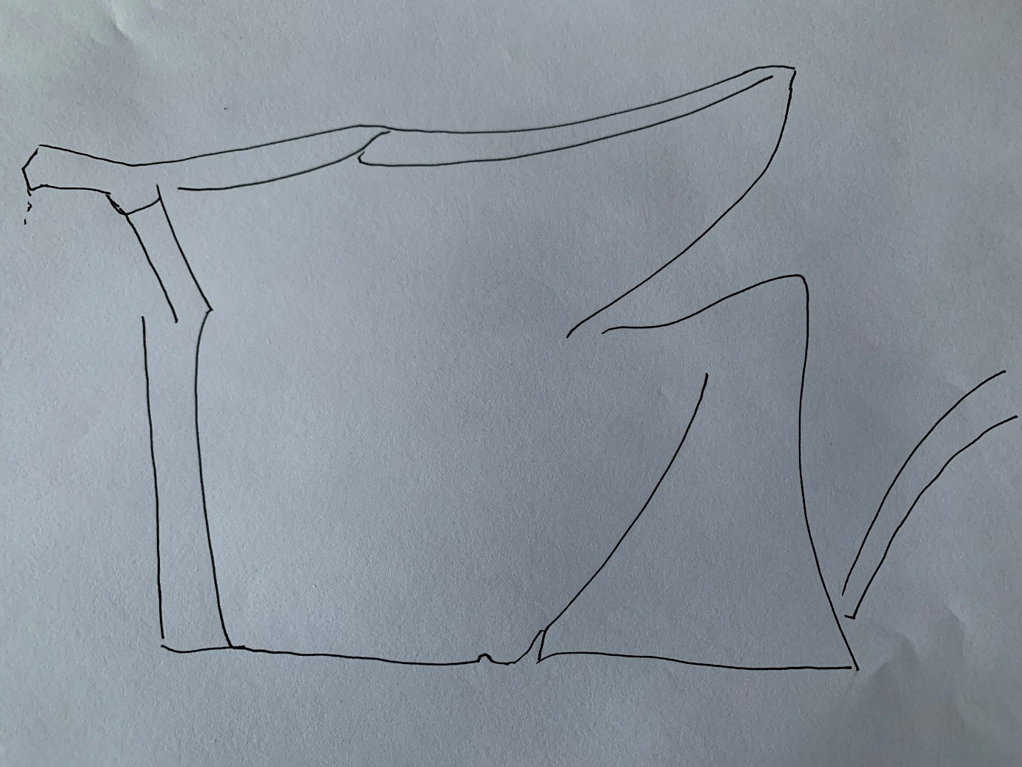
(Also available as a separate A4 sheet for ease of printing)

