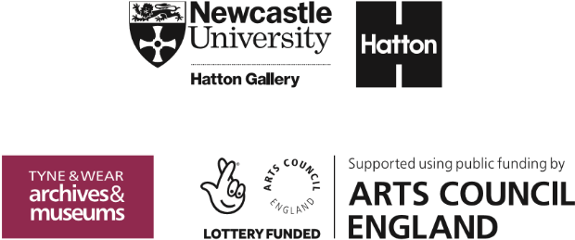
Hatton Gallery
Art Activities

Karin Jonzen (nee Lowenadler)
Bust of Fred Uhlman,
c.1976, terracotta

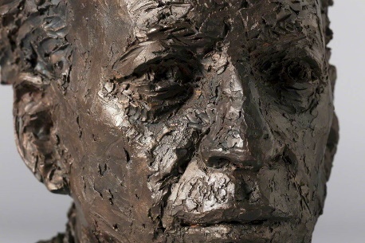
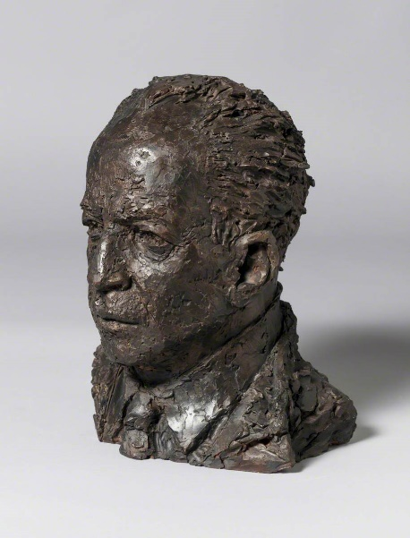
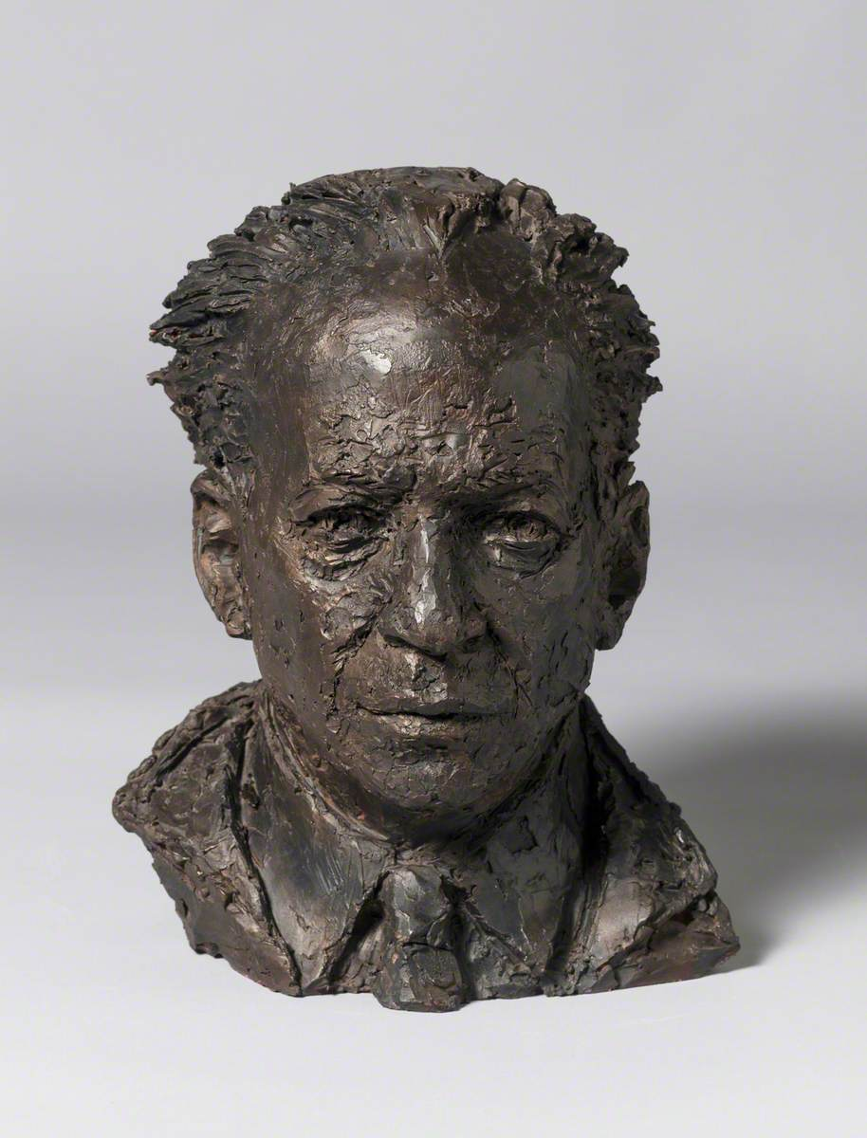
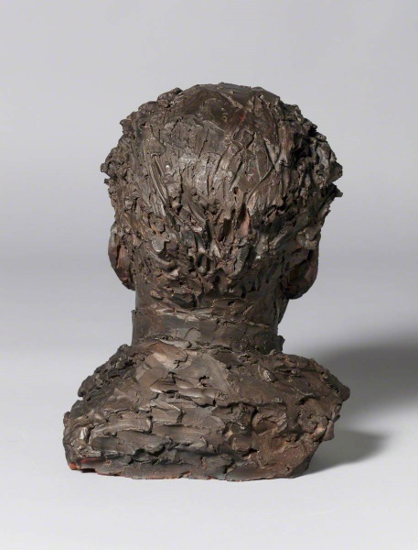
This portrait was made by the British artist, Karin Jonzen in the early 1970s. She worked extensively in a figurative style and made a living from both private and public commissions.
This bust shows the important Fred Uhlman who was a multi-talented and generous individual. Originally a German lawyer, he fled the Nazis in 1933 and became an artist in Paris. He later moved on to England where he was again persecuted, but this time by the British government, who interned him as an ‘enemy alien’ on the Isle of Man. There he met another German refugee, Kurt Schwitters whose important Merz Barn Wall is also at the Hatton Gallery. Uhlman gifted his entire collection of African art to the Hatton Gallery in 1984. The Hatton therefore contains a unique collection of very different artefacts from this era which can inspire many different lessons.
Artist information:
Karin Jonzen FRBS (1914-1998) was born in London of Swedish parents. She studied sculpture at the Slade under A. H. Gerrard. Jonzen became inspired by the sculpture of Ancient Greece upon visits to the British Museum. After three years at the Slade, she studied at the City and Guilds Art School in Kennington. Here, she devoted her time to stone carving: a material she would work with throughout her career.
During the Second World War, she worked as an ambulance driver at Spitalfields, but was invalided out with rheumatic fever. After bombing raids, Jonzen collected stone debris from the streets, taking the stone back to her garage to carve.
In 1948 she won the Feodora Gleichen Award for the best woman sculptor and was included in Herbert Read’s Contemporary British Art 1951. Her work was also featured in Eric Newton’s book, British Sculpture 1944-46, in which he wrote as follows of stylistic differences:
“Nonetheless, these sculptors can be conveniently divided into stylistic groups, according to their starting points. There are, for example, the devotees of pure form, led by Barbara Hepworth: there are the artists who have been inspired by Henry Moore’s noble fusion of human form with exciting anatomy of bones and caverns and mountains: there are the classic sculptors like Frank Dobson and Karin Jonzen and Dora Gordine who have by-passed the Italian Renaissance and gone back to the source of European Classicism, the Golden Age of Greece, and there are the complete traditionalists.”

Key stage: 3/4/5
Length: Range of project ideas outlined here

Resources required: Bar of soap, sculpting tools, internet access required for research tasks outlined in Extension section

Learning Objectives:
- To think in 3D
- To understand different choices, styles and mediums in art
- To develop an understanding of portraiture
- To think about the impact of the political and social experiences of the time on an artist’s choices and messages
- To apply lessons learnt from the study of Karin Jonzen to ideas, messages and mediums that are highly relevant today

Success Criteria:
- A soap bust
- A range of responses and development of ideas and learning through discussion/dialogue.
- Sketchbook work and final outcomes in both 2D and 3D.

Other curriculum Links:
- History: Experiences of refugees in Britain through the 20th and 21st centuries
- English:
- ‘Portrait of the Artist as a Young Man’ James Joyce
- ‘The Kite Runner’ Khaled Hosseini
- ‘A Land of Permanent Goodbyes’ Aria Abawi
- ‘Crossing’ Pajtim Statovci
- ‘Butterfly’ Yusra Mardini

Key vocabulary: stylistic groupings: realism, pure form/abstraction etc, context, low/high tensile strength, displacement,

Starter Activity:
- Explore types of portrait: equestrian, full length, double, half and bust. Ask learners to think of examples of each and why artists might select different types?

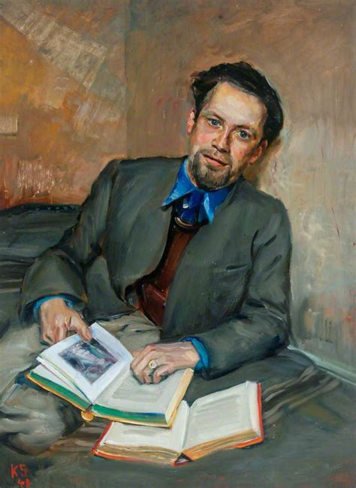
- What are the particular challenges of sculpting portraits? This work (above), by a British woman, Karin Jonzen is a bust portrait of the important artist and collector, Fred Uhlman. He donated his entire collection of West African objects to the Hatton Gallery in 1984.

- There is also a painting of the same man by his artist friend, Kurt Schwitters, (seen on the right here and also in the Hatton Gallery) painted when both of these German refugees were interned by the British government in an ‘Enemy Alien’ Camp on the Isle of Man. Jonzen’s work shows Uhlman 30 years later and is an interesting comparison with the black and white photograph taken by Terry Smith in 1977 when Uhlman was 76, in the National Portrait Gallery collection (Link here: https://www.npg.org.uk/collections/search/portrait/mw271393/Manfred-Fred-Uhlman)

Context
Although we may think we quite used to women artists today, it is important to remember how different attitudes were in the past.
Imagine living in the world of 1896, when George Frampton said about women artists: 'no matter how poetic the idea, how ethereal the finished bas-relief or statue... the art of the sculptor in its noblest form demands strenuous labour so that you may regard it as being tolerably secure from invasion by the new woman, or the mere dilettante; for it is a most perfect instance of fine art inextricably allied with fine craft.'! Jonzen lived later than this but despite achieving great success as a young woman, once she married and had a child, she found it very difficult to gain access to important commissions. KS4/5 students might be interested to research the work of any woman artist and see whether their ‘artist information’ begins with their marital status or details of their artistic innovations and style…?!

Links across time:
Sculpted Portraiture from the Roman empire, through Renaissance and Baroque to Rodin Giacometti and Jonzen.
Jonzen’s work in public spaces: link to Festival of Britain, Henry Moore, Barbara Hepworth, Antony Gormley, Edvard Eriksen. Exploring water in public spaces: from Bernini to Nikki Saint Phalle and Olafur Eliasson and on the Fourth Plinth from Marc Quinn to Heather Phillipson.
Using the shoes in Jonzen’s The Gardener to create links across time from Van Gogh and Courbet to Gyula Pauer, Meret Oppenheim and Willie Cole.

Description of project: Creating a bust portrait from soap ’stone’
- Looking carefully at the Karin Jonzen bust, notice the depth and detail of surface carving and the way the overall shape has been carved ‘in the round’.
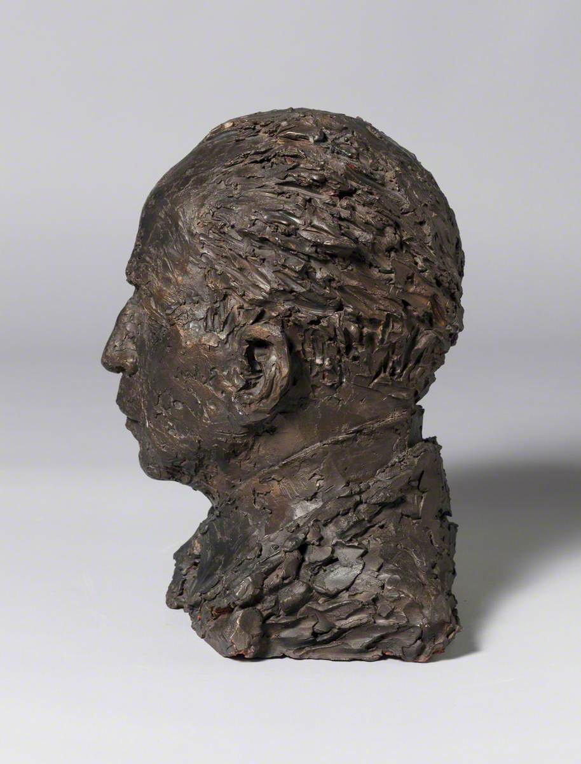
- Ask each student to think of the subject of their intended portrait. Jonzen’s bust of Uhlman shows a man who was vivacious, learned, generous, had survived many of life adversities and set a role model of philanthropy which continues to be enjoyed by visitors to the Hatton Gallery today. Will your students pick someone they know and love or someone they don’t know personally, but admire and feel they are important for us to acknowledge? David Attenborough or Greta Thunberg are popular relevant choices today, but encourage your students to think carefully about their figure before starting.
- Ask them to draw an initial sketch of the person and explain in a couple of paragraphs WHY they think they are important and WHAT characteristics they want to show.
- Give each student a bar of soap and range of sculpting tools. (This can be done as a homework task is preferred with strict instructions to clear up behind themselves and to be careful about their choice of tools!)
- Discussion of the choices of each student will make for an interesting debate about the values of art and purpose over time. Remind students that this is primarily an experiment in understanding the challenges of working in a low-tensile material and reductive system – ie when they cut too deep, it cannot be reattached. This lesson is a great example of learning from mistakes and enjoying them rather than building a fear of failure.
- In the next lesson, look again at the achievements of the Karin Jonzen bust and introduce students to some more extraordinary examples, such as Bernini’s Bust of Costanza (1637) and Janine Antoni’s Lick and Lather (1993). Notice the extraordinary detail in Bernini’s work. Shockingly, the artist later slashed her face after he discovered her having an affair with his brother. Antoni made her Lick and Lather pieces by licking a solid lump of chocolate or rubbing away at a bar of soap with water to create her own self-portrait. She made each one seven times to remember the ancient Greek ideal of proportion (that the perfect ration was a body equivalent to seven heads high).
- This is a great way of making art-history more meaningful to students – and their soap challenge will stay with them for years. End the project with a look at Bernini’s Apollo and Daphne (1622) and explain the story (from Ovid) that, fearful of being chased by Apollo, Daphne sent a message for help to her father – who turned her into a tree! Bernini creates the moment of transformation on this work which is extraordinary for his ability to carve finger-nails as leaves, toes changing into roots and skin to bark as it is for an amazing narrative. (Link to a video on this work below.) Made by the Italian sculptor when he was in his early twenties – an amazing defiance of what should (or should not) be possible in marble.

Other useful links: URLS to webpages:
Smart history resources are always excellent with a combination of formal analysis and historical context in short, accessible videos:
Bernini Apollo and Daphne: https://youtu.be/bdnPdZMZ9PU
Portrait bust of a Flavian Woman: https://youtu.be/mZNePcNPEBk includes an interesting exploration of contemporary hairstyles and influences
Artist, Wilfredo Prieto on Auguste Rodin’s sculptures: https://youtu.be/shAaKh7dR9g about translating ideas and the challenge of raising your skills
An introductory lesson on describing a work of art. Develop the essential skill of visual analysis in your students by exploring Henry Moore’s Reclining Figure: https://youtu.be/Mbvaz0EPK_g
Students exploring location, water and/or abstraction/realism in British art will find this short video on Barbara Hepworth’s Pelagos ‘Sheltered by the Sea’ an interesting comparison to Jonzen’s realistic style. https://youtu.be/TMUAYeygy5U
Fourth Plinth Schools Award (London schools only/deadline 12 March 2022) : but the templates are good for everyone: https://www.london.gov.uk/what-we-do/arts-and-culture/current-culture-projects/fourth-plinth-trafalgar-square/fourth-plinth-schools-awards-2022

Possible Follow Up Work/Extension Activities:
- Karin Jonzen was still something of a pioneer as a young woman artist of her time. She was also the youngest sculptor to contribute to the 1948 Exhibition of Open Air Sculpture in Battersea Park organised by the then newly created Arts Council and at the 1951 Festival of Britain. These activities established her reputation. Her work Symbolising Youth rose out of the waters near the Boat Dock of the Shot Tower on London’s Southbank. You might compare this to Antony Gormley’s Another Place (2005) on Crosby Beach or to The Little Mermaid (1913) by Edvard Eriksen which has become the iconic symbol of Copenhagen. Challenge your learners to make their own response to this by creating a ‘Symbolising Youth’ for 2021 in a venue of their choosing?
- If your students are interested in the interaction between art and water: they might be inspired by some of these earlier fountain works: Bernini’s Baroque masterpiece ‘The Fountain of Four Rivers’ (1651) in the Piazza Navona in Rome; Nikki Saint Phalle’s Stravinsky Fountain (1983) next to the Centre Pompidou in Paris and Olafur Eliasson’s The New York City Waterfalls (2008) in Manhattan. Of course, Duchamp’s war-time, Dada work ‘Fountain’ (1917) will be a useful provocation here too!
- Alternatively, Jonzen’s understanding of the links between place and artwork also creates lots of possibilities for student projects. Her works for the newly established World Health Organisation (WHO) in both Geneva and Delhi are sensitive to the idea of health as mental, physical and social well-being rather than just the absence of disease. As world health and indeed the role of the WHO has never been more closely scrutinised than in the last two years, how would you students respond to the request for an artwork which affirmed the importance of mental, physical AND social health?
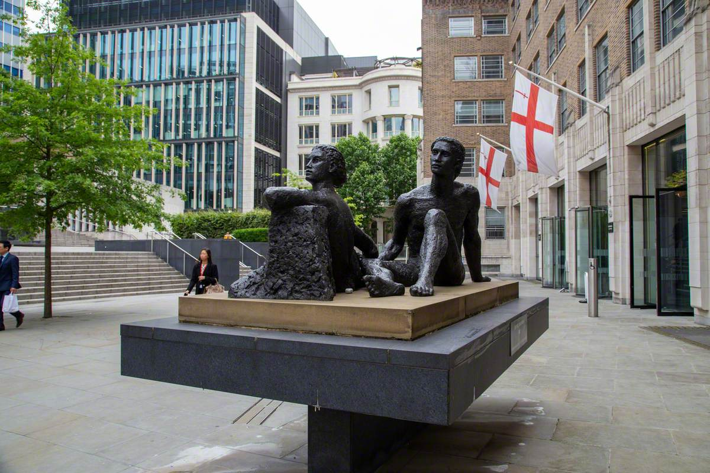
- In the post war years, Jonzen’s artistic peers were Henry Moore and Barbara Hepworth. Moore made a public artwork for UNESCO in Paris and Hepworth for the UN in New York while Jonzen worked for the WHO. Since then, her figurative style has lost favour with many critics but likeness still has a role in art, particularly portraiture – bringing us back to the Hatton bust of Fred Uhlman. Turn this into a student ‘balloon debate’ asking students to work in teams to argue for abstraction, realism, idealism and symbolism. Use the question ‘This house believes that abstract art is the most effective and meaningful way to inspire people today.’ Each team needs to prepare their own case with evidence in the form of different examples, but as they must also to prepare to ‘rebut’ the case of the other teams, they will need to think broadly and be nimble and flexible in their arguments. This can be an excellent way of making students think about meaning, message, location and purpose as well as the skills of making and process. All are helpful attributes for those wanting a career in the arts.

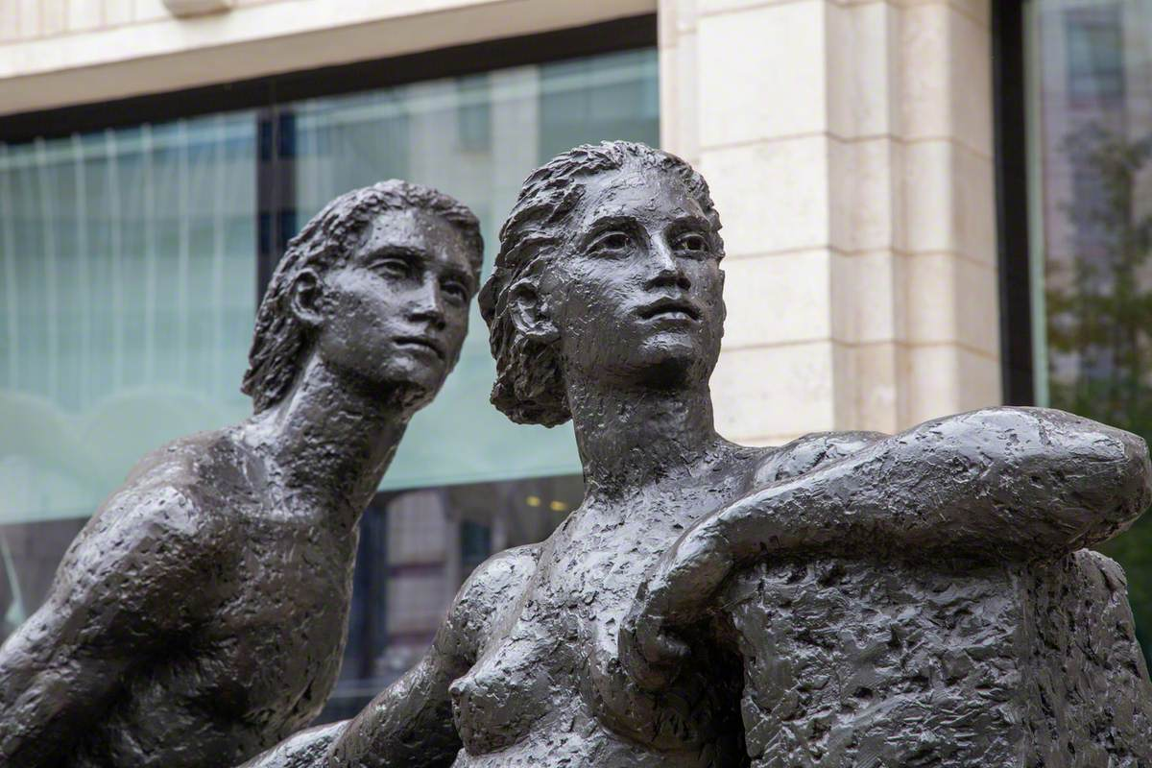
- Jonzen’s other public figurative works in London include the enigmatic ‘Beyond Tomorrow’ and ‘The Gardener’. Both of these titles have huge relevance today as students become increasingly concerned by climate change and the need to restore our planet. Both titles could be reused as an artistic project in either 2D or 3D. If you want to encourage your students to think about large scale outdoor installations, the Fourth Plinth project has useful templates for plinths. The inaugural work on the plinth was Marc Quinn’s ‘Alison Lapper Pregnant’ (1992) and, like Jonzen, he was fascinated and influenced by the Greek sculptures in the British Museum.

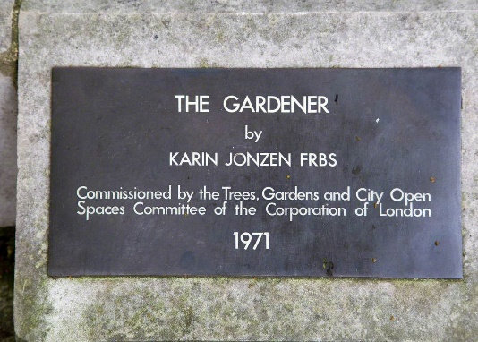
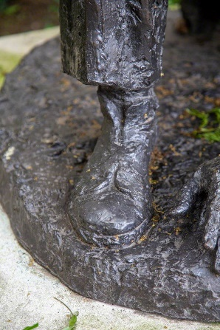
- Alternatively, the shoes and earthy realism of ‘The Gardener’ might make an interesting link back to explore the realism of Van Gogh’s Shoes (painted repeatedly between 1886-8) or Courbet’s Stonebreakers (1849) or the haunting power of Gyula Pauer’s The Shoes on the Danube Promenade’ (2005) in Budapest. More conceptual shoe works which make for fantastic student discussion include Willie Cole’s Lizzy (2013) and Zebratown Mask 2 (2013) and Meret Oppenheim’s My Nurse (1936). Guaranteed to want to make your students raid the local vintage shops!

Photographs: © the artist's estate. Photo credit: Alfred Yeung / Art UK

