Hatton Gallery
Art Activities

Title: The War Game
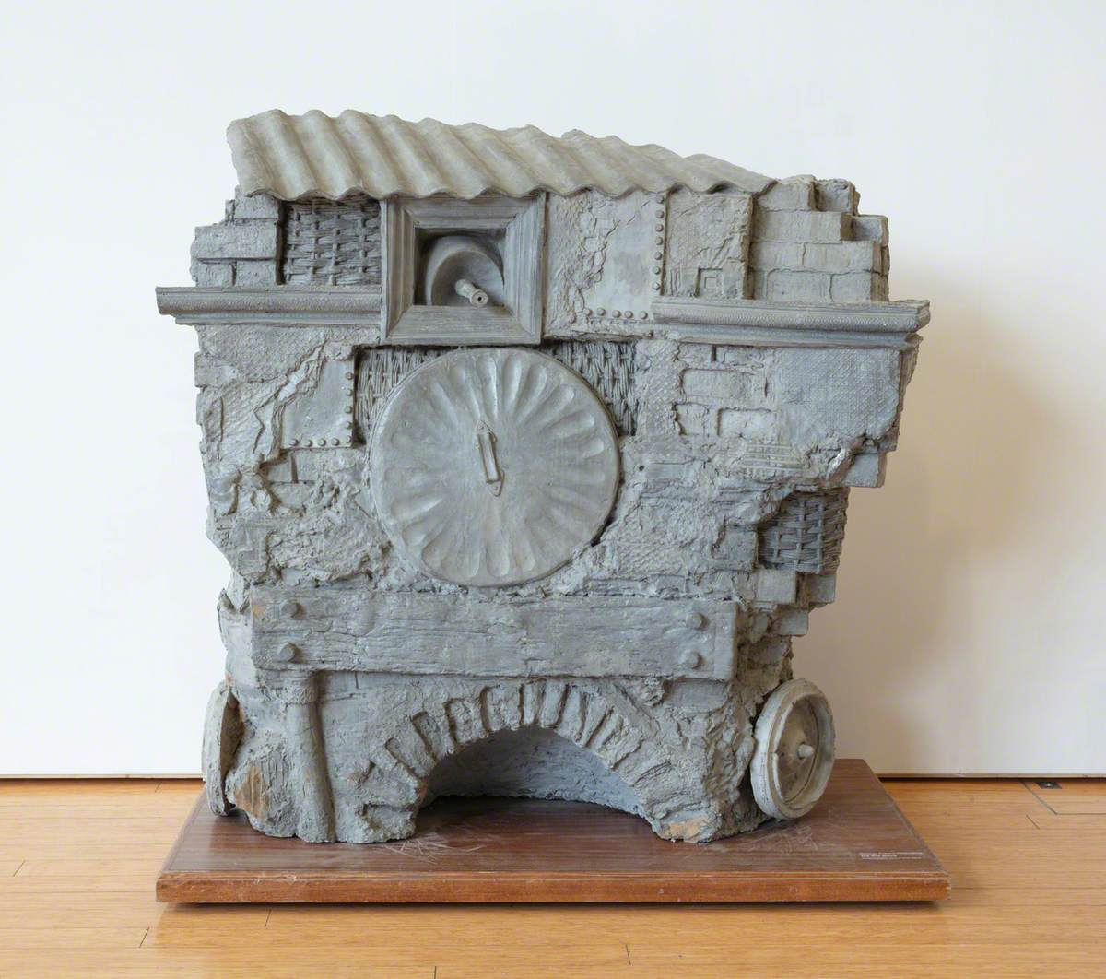
Work of art chosen: George Fullard – The War Game
https://artuk.org/discover/artworks/the-war-game-266158
Artist information:
George Fullard (1923-1973) was a British sculptor, teacher, and a talented draughtsman. He was born in Sheffield, Yorkshire and was the son of a miner. Fullard was highly regarded for his sculptures in metal & wood, and for his assemblages created using junk and various objects from toyshops.
George Fullard studied at the College of Art in Sheffield between 1938 and 1942, during which time the Second World War began. Fullard witnessed the terrifying Sheffield Blitz of 1940 and went on to join the armed forces in 1942; serving with the 17th / 21st Lancers as a gunner-operator in a tank. He suffered severe injuries and narrowly avoided death during the battle of Monte Cassino in 1944 when a shell pierced the armour of his tank and exploded. This resulted in Fullard receiving life-changing injuries with permanent scars to his head and shoulders.
He returned to his studies after the war, attending the Royal College of art between 1945 and 1947. Fullard took charge of the sculpture department at the Chelsea School of Art in 1963 and continued to create work until his premature death at the age of 50 on Christmas day, 1973.
The traumatic experience of war was a central theme in Fullard’s artwork throughout his career. The writer Michael Bird wrote a book about George Fullard and noted that the artist created “phantasmagorical fusions of battlefield trauma and childhood games”.

Key stage or year group:
KS3 / KS4 GCSE

One off lesson or sustained project (recommend time)
Three or more lessons initially with the option of developing into a longer sustained project

Resources required:
Cardboard (a variety of thicknesses including packaging cardboard, corrugated card etc.), Cardboard tubes, Scissors, Craft Knives, Cutting Mats, Tape, Glue, Pens, Pencils, Paper
Clay, Plaster, Containers, Water, Toy soldiers (possibly other toys)
Optional additional resources:
Hot glue gun, other appropriate objects and recycled materials.

Learning Objectives:
- To understand the work of George Fullard and gain an insight into his artistic practice.
- To consider the way in which traumatic experiences can shape artistic output, and how art can be used as a way of coping with trauma.
- To promote co-operative group work and discussion.
- To develop an understanding of sculptural processes such as cardboard construction and plaster casting.
Success Criteria:
A range of practical responses and development of ideas through discussion and dialogue. Sculptural responses (large group work and smaller plaster casts). Drawings combining observational skills and imagination.

Other curriculum Links:
History: World War 2 (The Blitz, Battle of Monte Cassino)

Key vocabulary:
Assemblage, Sculpture, Mould, Cast, Casting, Form, Shape, Texture, Juxtaposition, Armature, Conflict.

Starter Activity:
Learners will view the work of art “The War Game” by George Fullard ensuring they observe multiple angles of the work. They will answer questions based on their initial observations.
- How do you think this artwork was constructed?
- What does it look like? Does it remind you of anything?

Introduce George Fullard and his background / history

Description of project: step by step

Step One – Group Discussion and questioning:
Talk to the learners about this piece of work and the method of its construction. You could also show additional images of sculptures and assemblages by George Fullard.

Key questions
- Art historians have suggested that the sculpture could resemble some kind of barricade. Which items and objects can you see in this barricade? (Look at the front, back and sides)
- Why might George Fullard want to create an artwork resembling a barricade?
- What can you see in the sculpture that suggests it may have something to do with Fullard’s experience of war?
- What might the small circles resemble on the sides of the sculpture? (Could they be wheels? / could the structure move?)
- What did George Fullard do in the war? Could the sculpture be a reference to his role as a tank gunner-operator in the army?

Context
Fullard made “The War Game” in 1962 and it exists as two versions. The artwork in the Hatton Gallery collection consists of plaster, paint and a metal armature. There is also an additional version cast in bronze. Fullard created this sculpture by taking clay casts from items such as wicker baskets, bricks, timber, rivets, a door, and other objects. These pieces were assembled into a structure with two main faces (or walls), and two narrow sides.
The front wall of the structure appears to be an improvised defence made from baskets, corrugated sheet metal, timber, bricks and a dustbin lid. A machine gun barrel emerges from a hole near the top of the structure.
On each side of the structure there appears to be a wheel, suggesting the building might be able to move.
The back of the structure consists of damaged brickwork and three steps leading to a door.

Step Two - Group sculpture task
The first practical task will involve making a group sculpture using cardboard (…it could possibly be a series of sculptures depending on the size of the group). The sculpture will be life-size so it will be important to collect plenty of cardboard prior to this task. It would be useful to point out that this method of construction is different to that used by Fullard when he created ‘The War Game’ as he made it using casts from real objects. *There is a section about casting later in the project but for this task, the idea is to create something of a similar scale to the piece (148cm x 146cm x 72cm)
Learners will recreate individual sections of ‘The War Game’ using cardboard and recycled materials. They will then assemble a complete version by combining their individual pieces.
You should demonstrate some cardboard construction techniques including building up layers of cardboard, cutting, sticking and assembling. If craft knives are used, ensure all learners observe appropriate health and safety guidelines.
Learners could decide on (or be assigned) elements of the sculpture to recreate. Options would include brickwork, timber, rivets, wheels, door, corrugated sheet metal, dustbin lid, machine gun, wheels etc.
Ask the learners to look at the forms and the shapes in the sculpture. Ask them to think carefully about the details and the textures of the surfaces, how might these surface textures be recreated using cardboard?

Rules
Inform the learners that because the title of this work is ‘The War Game’ and games usually have rules, there will be rules to this task.
- The structure they create as a group must be hollow, the inside of structure must be accessible, and there must be room for at least one person to fit inside of it.

Step Three – Drawing and understanding
Key Questions
- Do you think that George Fullard’s sculpture (…or the sculpture that you have just built) could withstand a real attack? Why? Why not?
- Is it a building / structure designed for war?
- What was the intention of its design?
- Would you consider it a “safe space”?

Talk to the learners about the sculpture acting as a place to play or acting as a safe space (in terms of it being somewhere into which the artist could retreat). It may not necessarily be a sculpture of a physical fortress or a real barricade; but it could be more like a childhood den or a place that has happy memories.
Discuss the word “Game” in the title “The War Game”.

Context
Writer Michael Bird says that the doorway looks like it could open into the living room of the terraced house in which Fullard grew up. He has described as being “a threshold between real life and play”. He also describes the sculpture as looking like a “backyard shed that has been turned into an imaginary fortress by children”. Bird goes on to say “Through the retelling and remaking of his battlefield experience in the form of ‘games’, Fullard may have been able to contain or step outside the trauma”
Fullard created a collection of drawings known as the ‘Drawing relating to War Series’. These drawings are not dated but we believe that Fullard created them around the same time as ‘The War Game’. In one of the drawings, a young girl holds a doll and stands inside of a building on wheels. We do not know if Fullard doodled this picture before, or after the construction of the sculpture but it clearly has a direct link to the piece.
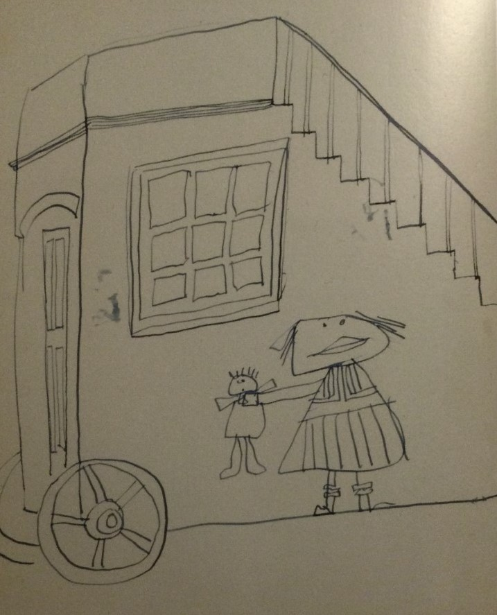

Drawing relating to war series, Ink on paper. 25.5 x 20.2 cm, c.1962, Henry Moore Institute Leeds.
For the next practical task, learners will create drawings using the sculpture they have built as inspiration.
- They will create observational drawings (this could be large drawings using chalk and charcoal, or smaller pencil / pen drawings)
- They will also create drawings from their imagination. They will consider the shape and form of the sculpture but they will also imagine and draw the interior of the space. Which objects or memories might they include in their own safe spaces?

Step 4 – Casting
In the third practical stage, learners will make moulds and casts using clay and plaster.
Fullard created ‘The War Game’ by casting objects he found in various places; including objects picked up from bombsites, which remained untouched for a long time after the German bombing raids of the war.
Learners will roll out small slabs of clay (around 1cm to 1.5cm thick). They will push toy soldiers, and any other appropriate objects, into the clay. They need to push far enough to leave an indentation but not so far as it goes completely through the clay. Objects can be removed from the clay and reused. Learners should experiment with covering the surface in order to create interesting textures.
Learners will then construct clay walls (of roughly 2cm) around the slabs creating a watertight barrier. Learners can then pour liquid plaster into the mould. When the plaster is dry, the clay can be removed from the plaster leaving a detailed plaster cast.
Learners could make multiple casts and put these together to create a structure.

Other useful links: URLS to webpages etc
https://www.lundhumphries.com/blogs/features/happy-birthday-george-fullard-by-michael-bird
https://www.tate.org.uk/art/artists/george-fullard-1131
https://www.pangolinlondon.com/artists/49-george-fullard/overview/
https://www.contemporaryartsociety.org/news/friday-dispatch-news/age-terror-art-since-911-imperial-war-museum-london/
https://www.lindahubbardart.com/costumes-of-war.html

Possible Follow Up Work/Extension Activity:
Learners could develop projects in independent directions, especially if you are using the resource for a GCSE project.
Independent starting points might include – War / Safe spaces / Comforting objects / Juxtapositions (between trauma and comfort, real life and fantasy, childhood innocence and conflict, etc.).
Learners could look at the work of Grayson Perry, especially his work containing references to the war games he played as a child. Perry often combines images of war and destruction with images relating to toys and childhood. You could encourage learners to read the book ‘Portrait of the artist as a young girl’ by Wendy Jones, which documents the war games Grayson Perry played growing up.
Learners could research work from the 2017 exhibition ‘Age of Terror, Art since 9/11’ at the Imperial War Museum in London.
You might introduce learners to the work of contemporary artist Linda Hubbard and her ‘Costumes of War’ series, in which she has created artworks juxtaposing childhood objects alongside the theme of war. This series consists of artworks such as a baby’s sock cast in bronze and turned into a war medal; and a dummy painted in camouflage colours. Please note that some of these works contain upsetting images and language. You might want to select images to be shown, especially if the learners are of a younger age.

