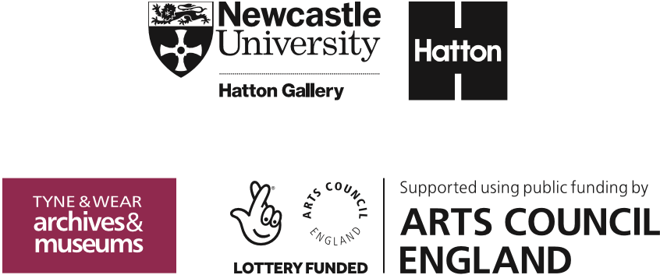
Hatton Gallery
Art Activities

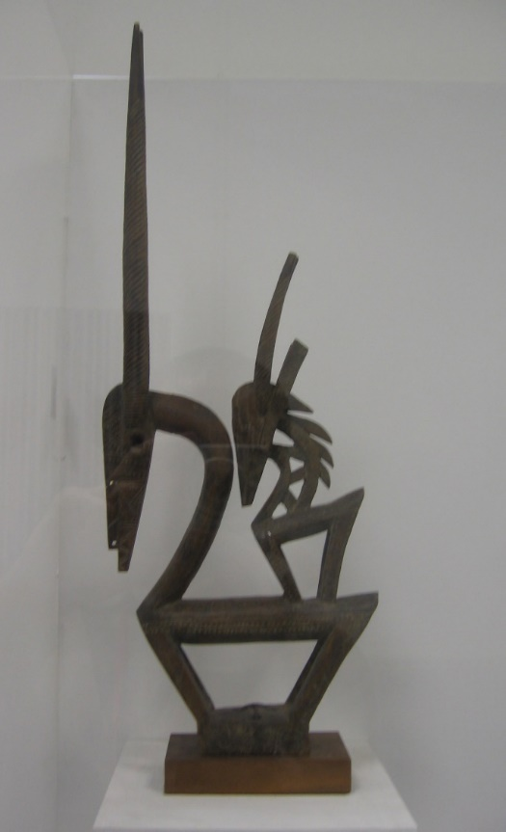
The Chi Wara from the Fred Uhlman Collection
(Left) Male Chi Wara (roan antelope):
- Collection no: 1984.003
- Size: 125.38.11
(Right) Female Chi Wara (oryx antelope), carrying a male child:
- Collection no: 1984.004
- Size: 75cmx75cm

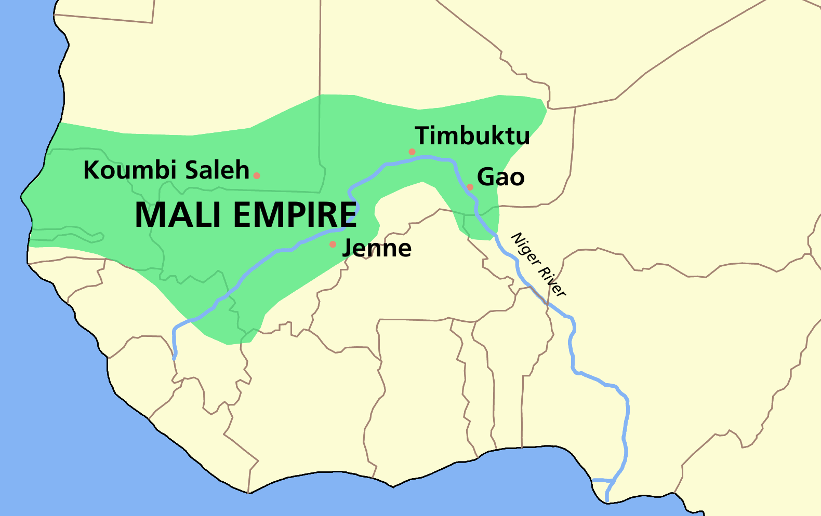
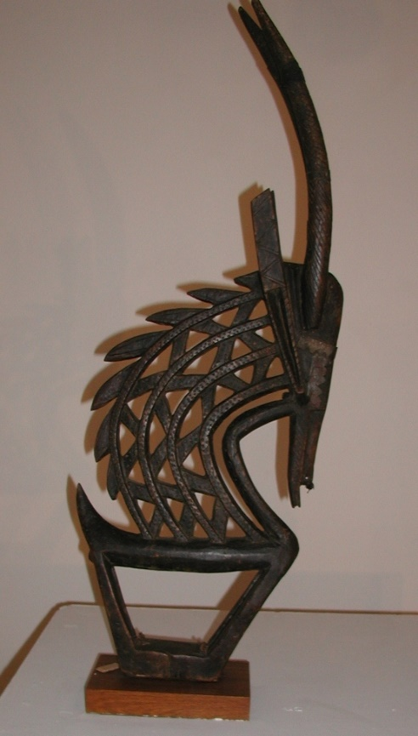

Artefact information:
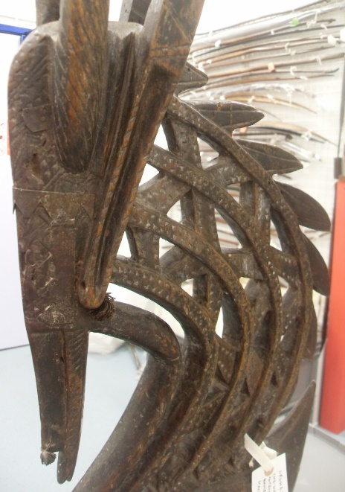
Bamana (Mali) mythology tells how the heroic Chi Wara, a half-antelope and half-human figure, taught agriculture to man. Pairs of male and female Chi Wara headpieces are worn by young farmers in a dance that takes place in the fields after they have been seeded and again at harvest festival. As they dance, the farmers pierce the earth with their sowing sticks to make it fertile for the growing season, while a chorus of women follows, singing praises. The dancers’ movements remember both the antelope running across the land in a celebration of harmony between man, beast, nature and the food it provides and the action of the farmers in planting the seed.
But when humans gradually became careless and wasteful, the Chi Wara (sometimes written Ci Wara) was said to have buried himself in the earth. This message may strike a chord with many learners today who are increasingly concerned about how we can restore the harmony between humanity and the natural world that feeds and protects us.
These Chi Wara are head-dresses. Although the dating is uncertain, they probably date from the 19th century and are made of wood. The wooden sculptures you see here would have been fastened to a woven cap. They were made by the blacksmiths of the village – presumably because they had a studio to work in and were used to providing the tools for farming. Perhaps this explains the way the wood has been worked to resemble metal with extensive negative space? As Mali was colonised by the French in the late 19th century, we imagine that these pieces were taken back to Paris and bought by Uhlman from a market there.
The wooden headpiece on the left represents the female antelope carrying her baby on her back just as the women did in the fields. The baby fawn on her back symbolises all of humanity. The larger headpiece on the right represents a male antelope. The zigzag path of the mane represents the sun’s rays and the horns symbolize a stalk of millet, a staple of the Bamana diet. The headpiece was originally attached to a basket-shaped hat which had long raffia fringe cascading around the wearer, symbolizing water flowing down to the earth.
The arrival of African artefacts from the colonised French lands generated huge interest in Paris at the beginning of the 20th century. The striking simplicity and elegant linearity of these shapes were an inspiration to the early European Modernist artists such as Picasso, Matisse, Braque, Brancusi and Giacometti. These artists were interested in the power of these works to change and challenge the European traditions of idealising (making perfect) and realism (copying life-like detail) that had dominated the European art scene for centuries and now seemed tired and unoriginal. Although they did not know any of the ritual meanings of these works, they were fascinated by the ways they suggested new ideas for art. In more recent times, artists have been fascinated with the Chi Wara for both their formal and ritual properties and this resource contains links to some further names to look up.

Key stage: 3-5
Length: Any
Resources required: Depending on the chosen activity: paper, card, raffia/string/wool, scissors/scalpel, cutting board. Colour if wanted.
Learning Objectives:
- To think about the ways art and making can lead to a wide range of careers
- To learn from, share and empathise through discussions on the dialogue between man-made and the natural
- To develop an understanding of the early European modernist styles (particularly Fauvism and Cubism)
- To think about the power of story-telling through words (literacy), action (drama) and the visual (art) and the ability of these to work together to change minds and behaviours.

Success Criteria:
- Understanding simplification and line work in 2D
- Experimenting with 3D work in a variety of materials
- Creating work individually and as a complete class
- Researching the influence of African artefacts in early European Modernism

Other curriculum Links:
- RS: different global religions and practices.
- English: Chinua Achebe explores Igbo (Nigerian) cultural practices in ‘Things Fall Apart’
- German ‘Fred Uhlman’s novella ‘Reunion’
- Drama: having watched the Lion King videos (links below) could you develop/perform a story using your headdresses to challenge ideas on an issue that is important to you today?
- Geography: understand traditional farming rituals and the changing practices in Mali in modern times

Key vocabulary:
*Cultural appropriation is when a tradition, such as clothing or a hairstyle, is taken from a culture and used in a different way. It can cause offence when people do this without making it clear where the traditions come from, or when they don't acknowledge how important they are to certain cultures. This can make people feel as if their culture is not being respected.

- Ritual and religion
- headdress,
- spirituality and status
- cultural appropriation* (when is copying/borrowing from another tradition controversial and why?),
- griots (memory keepers)
- the ‘primitive’ in art,
Starter Activity:
- Timed 5 minute starter: Look carefully at both images and draw them in silence with pencil on white paper. (This will give students a chance to look and think for themselves rather than be swayed by the contextual story you will tell.)
- Why are these works important? Why are they in the Hatton Gallery? Note down brief ideas or discuss in pairs and then come together as a class.
Hopefully, the range of suggestions from your learners will demonstrate the varied directions that you might choose to take this lesson in.
Some might say: because the simplification from the actual natural form of an animal is interesting – and perhaps easier to draw. (Ideas of realism, idealism, stylization, power, exaggeration…..)
Others might say: because someone collected them and gave them to the gallery when they died. (Ideas of ownership, curating, how museums acquire their collections…..)
Others might ask what were they used for? (Ideas of function in art, particularly in works from beyond the European tradition of decorative fine art…..)

Context
These Chi Wara were made in Mali – once one of the most successful empires in the world. Between 1300 and 1600 (at the time when Europe was fashioning its new Renaissance art based on the ideas of the ancient Greeks and Romans), Mali was twice the size of France and its richest and most famous ruler, Mansa Musa, was thought to be the richest man in the world with a fortune twice the size of Elon Musk’s today. He got this wealth from the mining of salt and gold in Mali and from the famous cities of Timbuktu (where books were the most important trading item and home to Africa’s grandest library) and Djenné (where The Djinguereber Mosque and Sankore Madrasah (whose interior walls are exactly the same size as the Ka῾ba at Mecca) still survive today. After he completed hajj (pilgrimage) to Mecca in 1324, Mansa Musa gave away much of his fortune, building mosques and feeding people all along the route from Timbuktu through Cairo to Mecca.
Your learners will also know the story of Mali’s early famous king Sundiata who ruled these lands from 1235-1355. Although they might not realise that his is the story of the Lion King. The real life Mufasa was King Nate Konate, Sundiata’s mother was Sogolon. Unable to walk as a child, Sundiata was mocked for his disability and resented by many. His mother fled with him and his sisters when Konate died, but Sundiata grew up wise and courageous and later came back to Mali to rescue his Mandinka people from the cruel and oppressive rule of his half-brother Sonmaraoro of the Sosso. During his rule, he established the Manden Charter in 1235, which is today recognised by UNESCO as one of the oldest constitutions of the world. This charter advocated social peace in diversity, education, food security, the abolition of slavery and freedom of expression: goals most of us share today! Older students might be interested to know that the Disney studios claimed that the story of the Lion King was inspired by the biblical stories of Jacob and Esau and by Shakespeare’s Hamlet. Another example of white-washing history?
In the ‘Scramble for Africa’, Mali was taken by the French. Independence was not restored until after the end of the second world war. Today, the Republic of Mali is the 8th largest African country, with a land mass of just under half a million square miles. Mali has just under 20 million inhabitants, and in 2017 it was estimated that 67% of these were under the age of 25. Today, the capital is Bamako. The Northern borders reach into the Saharan Desert and the Southern into the Sudanian Savanna. Both the rivers Niger and Senegal pass through.

Links across time:
Ask your students to research the work of Picasso, Braque and Matisse who were all hugely influenced by African masks and artefacts including the Chi Wara. Why did these artists think these works were ‘violent’ and ’dynamite’ but also solemn and beautiful?
The sculptors, Brancusi and Giacometti made extensive use of the ideas in these Chi Wara. Brancusi’s The Kiss (both 1908 and 1916 versions) explores the idea of the wave like ‘hair’ symbolising strength and unity. Giacometti’s shocking Woman with her Throat Cut and Hour of the Traces (Tate) both use the dramatic linear simplification of the Chi Wara to create powerful 3D works.
The art of African American artist Romare Bearden is inspired by European modernism, African tribal forms, Byzantine mosaics, and Chinese calligraphy. In the 1960s he achieved acclaim with the development of his photomontages which addressed political and social themes, cuts across colour boundaries, yet testifies to its cultural heritage. He translated well-known collages into monoprints and graphic works seeking to make his imagery more available to a wide audience: reworking learners’ painted cardboard cut outs inspired by the Chi Wara would make for great prints.
Cuban artist, Wilfredo Lam was also in Europe at the same time as Fred Uhlman and he too, was fascinated by these works. Tragically, he lost his wife, Eva and their new born son to tuberculosis a year into their marriage and so the female Chi Wara with its baby on its back must have been particularly poignant for him. You can see photographs of a piece very similar to the one in the Hatton in the photographs of his studio in Havana. Look for the Chi Wara influences in his monumental painting The Jungle which is often compared to Picasso’s Guernica.

Description of project:
There are so many ways that the Chi Wara could be used to inspire a group of learners:
- Ask them to select any animal and reduce it to its ‘essence’ (Brancusi) in an initial sketch and then a light-weight cardboard headdress. They might add collaged or recycled parts to this or paint decorate with simple lines as the Chi Wara have been.
- Although the Chi Wara were always gendered and used in male/female pairs, alternative pairings: winter/summer, night/day, aggressive/passive or comic/tragic might make really interesting variations. (And of course the last would recall the original use of classical masks to depict comedy and tragedy)
- Watch the videos linked here on the making of the Lion King. Could you join forces with other creative departments in your school and ask learners to write a story relevant to today, create headdresses to characterise the players and then perform it?
- Or even work with one of your local primary schools, to offer them headdresses for a performance or rethinking of a traditional story with puppets, masks and headdresses? Large scale work is both fun and demanding. Learners would have to think carefully about materials, balance and strength in this project. Working to a ‘brief’ might also inspire everyone to make sure their work was viable for its ‘function’ (in itself, this leads to an interesting discussion about the function/s of art over time and in different cultures.)
- Learners could learn from the linearity of these works to think about light and shadow. They could use their phones/torches to make more pronounced light through the negative spaces and then create an abstracted pattern from the result.
- The wider topic of headwear may link to both textiles, photography and sociology/anthropology studies. Over the centuries, head wear has been created to symbolise religion, status, power, protection and ritual as well as entertainment, fashion, class and profession. Ask each learner to research or think of a different kind of headdress (from the indigenous First Nation people of North America to the Catholic bishop’s mitre, is it too bold a claim to say that this is an item that has been present in every culture, every continent and in every century?)

Other useful links: URLS to webpages:
- https://smarthistory.org/male-and-female-antelope-headdresses-ci-wara/

- The Global Language of Headwear: Cultural Identity, rites of passage and spirituality. 30 second video for ideas here: https://ttugloballanguageheadwear.org/

- Dr Gus Casely-Hayford explores the influence African art had on Matisse and Picasso: https://youtu.be/INvS4Vty2wg
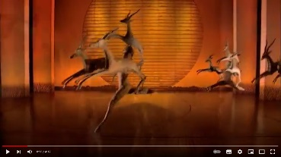
- Road to Pride Rock: Costumes, Puppets and Masks: https://youtu.be/x0DNDqVq-h0 (4 mins) Art as inspiration, careers and entertainment for millions

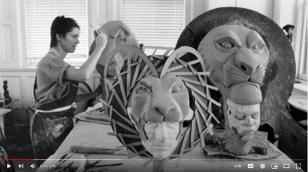
- **The Lion King: Masks and Puppets: https://youtu.be/OZrMmoW4BeA Interview with Julie Taymor and others to explore the global influences behind the artwork of the show. (5 mins)** (excellent)

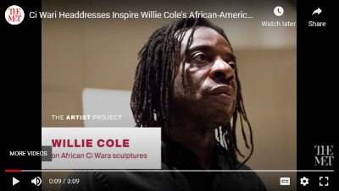
- Willie Cole, sculptor on the importance of the Chi Wara to his art and how “education makes us see things differently”: https://youtu.be/HPyDO80wxug

Possible Follow Up Work/Extension Activities:
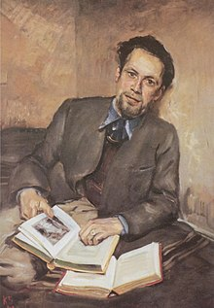
- The Chi Wara are part of the important Fred Uhlman Collection at the Hatton. Interned on the Isle of Man, Fred Uhlman (1901-1985) was an important artist and collector and is worthy of study in his own right. He was initially trained as a lawyer in his native Germany, but he fled to France in 1933 to escape the Nazis because of his Jewish origins. Refugees were not allowed to undertake paid work and so he finally got the opportunity to achieve his childhood dream to become an artist.
He married an Englishwoman and set up home with her in London, but in 1940, he was once again facing persecution – this time by the English authorities who saw him as an ‘enemy alien’ and he was sent to the camp on the Isle of Man where he met the German artist, Kurt Schwitters. They became great friends and Schwitters painted this portrait of Uhlman (which is also in The Hatton). Uhlman and his wife left their collection of African art to The Hatton so that it could be seen with Schwitters’ Merzbarn Wall and help visitors see the link between different types of powerful, experimental art. Uhlman was also an author, writing a short novel ‘Reunion’ about friendship between people from different backgrounds. If you were going to paint a portrait of a friend of yours, what props and pose would you choose?

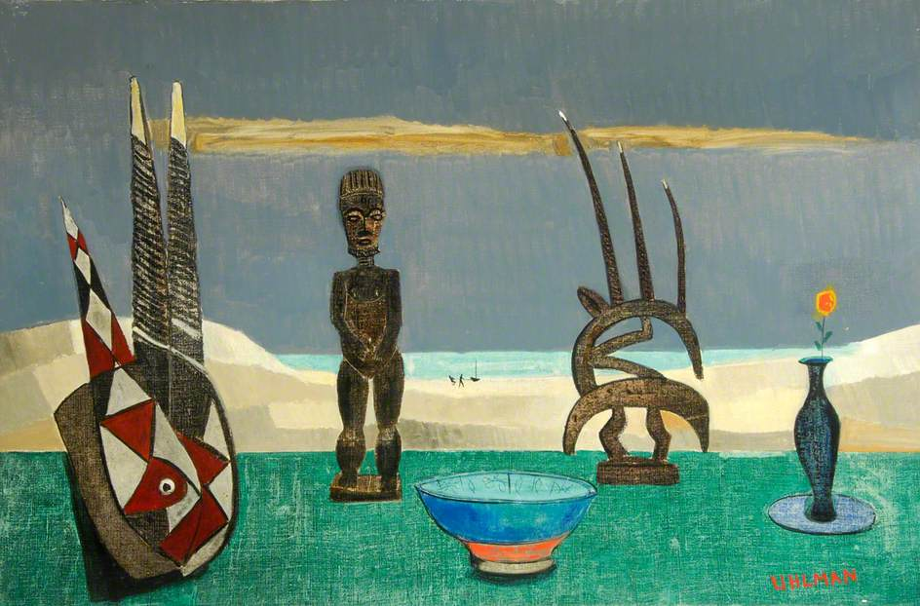
- This still life painting by Uhlman, also in The Hatton, shows him looking carefully at the Chi Wara and other works in the collection but using them inventively rather than copying them. Can you make your own arrangement of 3D still-life objects and then paint them on to a 2D canvas?

