Hatton Gallery Home Learning Resource
BLUE
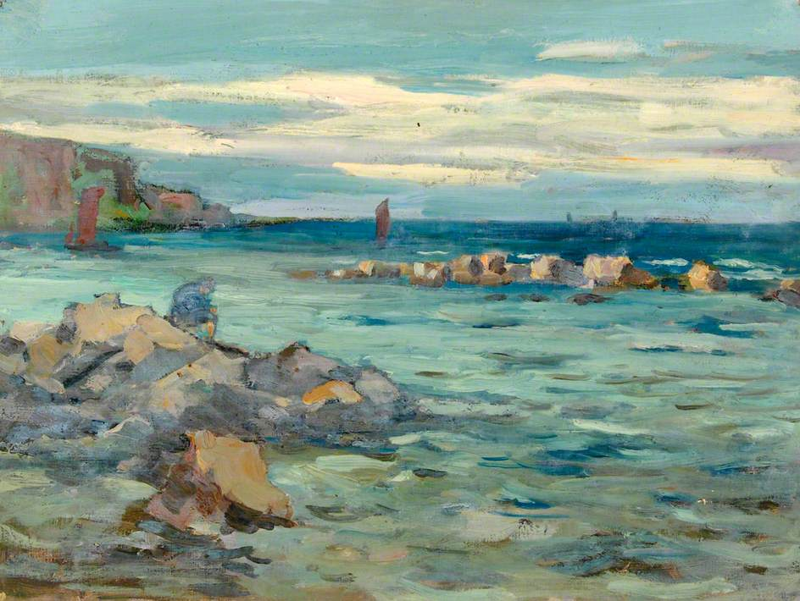
Seascape by William Henry Charlton
Look at all of the different shades of blue in this painting . The artist has mixed blue with white, purple and red to make all of these different colours,
If it was all painted one shade of blue there would be no movement or reflections in the water.

BLUE
Blue is a cool, calm colour and in a painting it often looks like it’s in the distance .
Can you think of all of the different meanings the colour blue has? How does it make you feel?
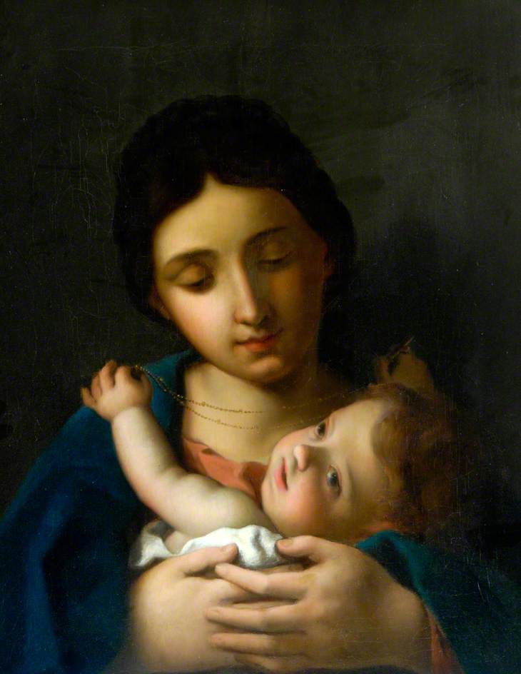
Blue is often used to show very precious things like the Madonna’s cloak in this painting. That is because the colour itself was very rare and expensive.
Madonna and Child based on a painting by Van Eyck
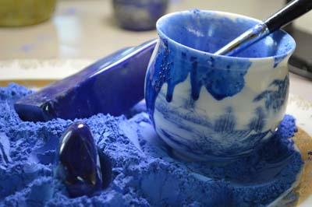
Blue was precious and expensive as it was made from a mineral called Lapis Lazuli which could only be found in certain mountains in Afghanistan. Merchants from Italy would bring the Lapis Lazuli back to Europe. It was ground into a powder with egg yolk added to it to make blue paint.

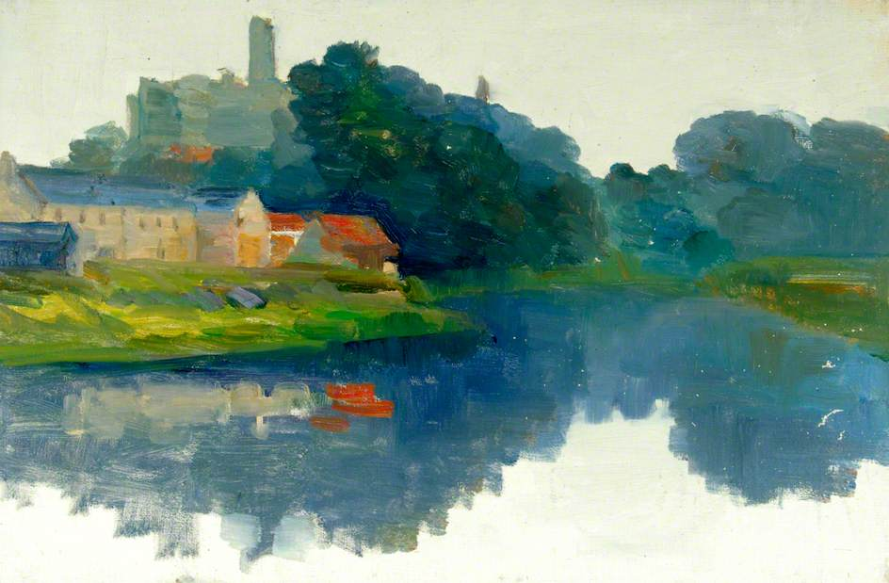
River Scene by W.H. Charlton
In this painting the artist has used blue for the trees in the background and also for the beautiful reflection in the front part of the painting called the foreground.

Can you write a poem based on this painting?
Here are some words to get you started :
reflection peaceful calm deep

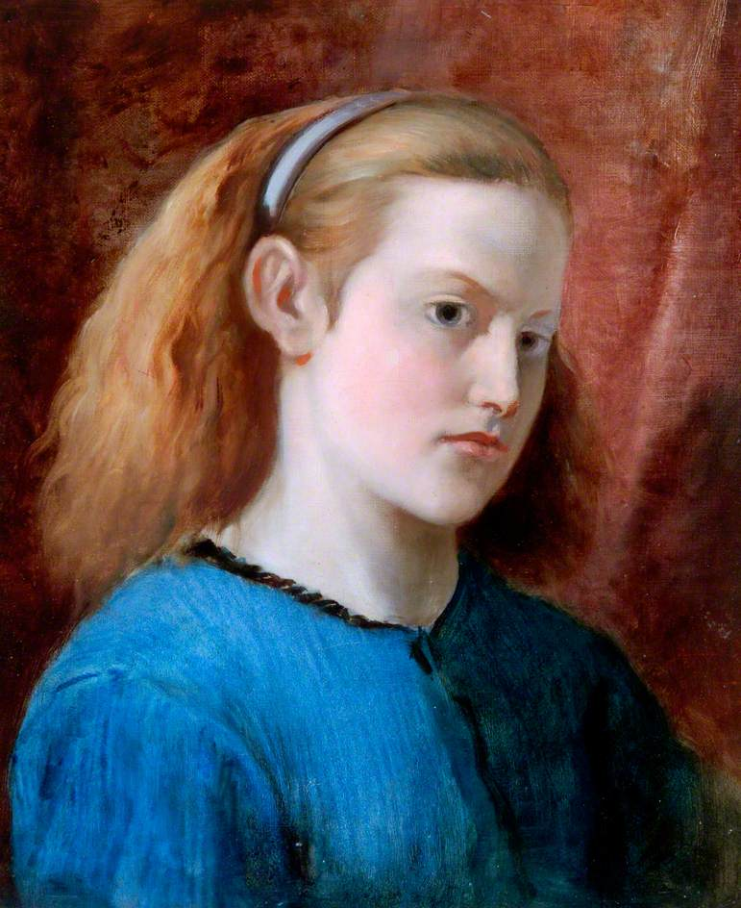
Girl in a Blue Dress by William Bell Scott
This girl would have sat in a chair to be painted by the artist. She looks like she is staring out of the painting at us but it’s because she was looking at the artist.
This kind of picture is called a three -quarter view portrait as the girl has her head slightly to one side. How do you think she is feeling? Look at all of the different small brushstrokes of blue paint on her dress.
Why is her dress dark on the right hand side?
Activity:
Now it’s time to have some fun
You will need: Thick paper,paints & palette to mix colours – this could be a plate
For this activity you have to use quite thick paper as the paint will be wet
First job is to mix up some blue with water in a palette or on a plate and leave it to one side.
Now paint your whole paper using just water and a big brush.
Now at the top edge of your paper paint a big band of your blue colour, pick your paper up and let the paint run down your sheet of paper.Mix up different shades of blue and keep painting like this all over the sheet .
It could be the sky? The sea? A river?

Share your red pictures with us!
Share your green pictures with us on social media:
Facebook: thehatton
Twitter: @hattongallery
Instagram: @hatton_newcastle

