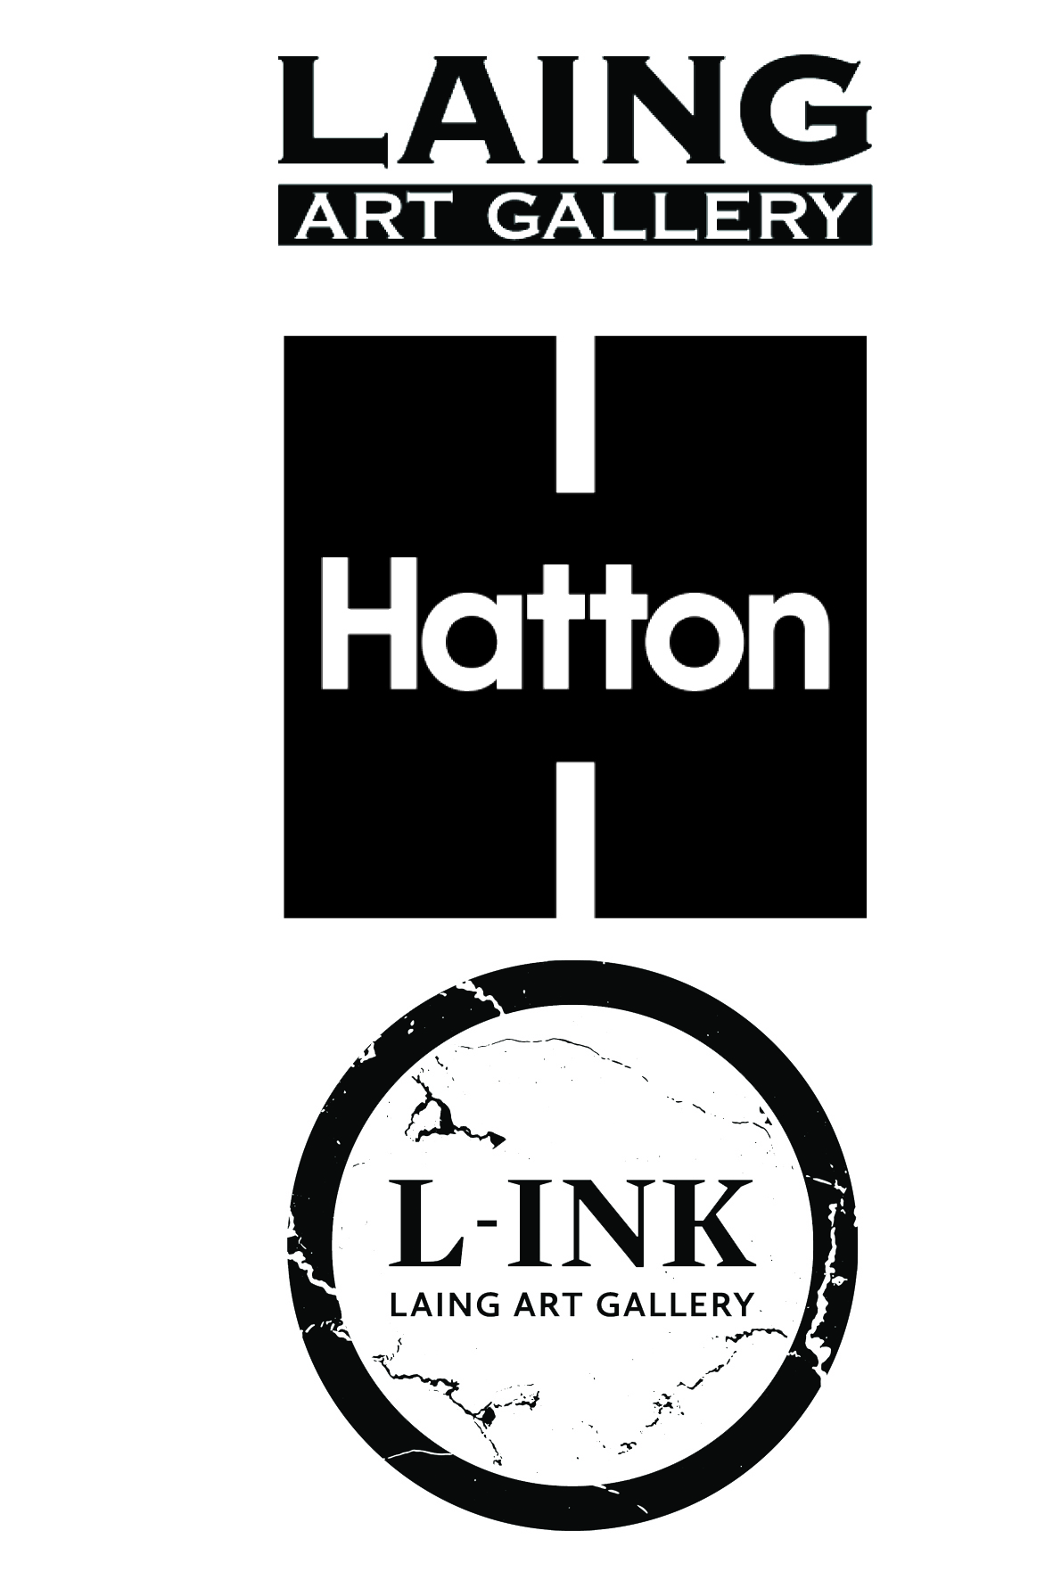
L-INK2019-20

Application Form
Please fill in your details and e mail to zoe.allen@twmuseums.org.uk
or post back to Zoe Allen at Hatton Gallery, Kings Road, Newcastle NE1 7RU

Personal Details
(to be completed by parent / guardian if the young person is under 18 years)
Name of parent / guardian
(If participant is under 18)

Telephone number of parent / guardian | Home:  Mobile:
Address

Young person's surname

Young Person’s Forename

Young Person’s email address

Young Person’s mobile number

Can we contact young person by text? | Yes / No (delete as appropriate)
Young Person’s Date of Birth

Travel arrangements: (i.e. how will you / your child be getting to the gallery –train, bus, walk, cycle?)

About You (to be completed by the young person who is applying to L-INK)
Please use this space to tell us about yourself and why you are interested in joining L-INK.
(No more than 500 words)

Medical Information
(to be completed by parent / guardian if the young person is under 18 years)
Does your child have asthma, fits or faints or any other allergy, illness or disability? | Yes/No  If yes, give details
Is your child allergic to any medicine/food/elastoplasts etc? | Yes/No  If yes, give details
Does your child have any specific dietary requirements? | Yes/No
Name and address of child’s doctor

IMPORTANT INFORMATION
to read before signing!
L-INK meet once each month, (unless stated). Link is a fixed-term project and we ask for a time commitment
of one half day per month plus one potential overnight trip to visit other galleries. We understand that participants have many extra curricular commitments and responsibilities as well as school work, so if participants find that they are unable to commit to the project, please let us know so that we can offer
places to others.

Signature

Parent / Guardian name ________________________________________________________________
(if child is under 18 years)
(Please print)

Signed _______________________________________________________________________________

Date __________________________________________________________________________________

Relationship to child: ____________________________________________________________________
(If applicable)

Emergency Contact telephone number(s) ___________________________________________________

Additional numbers to be contacted in an emergency

Name ________________________________________________________________________

Relationship to child__________________________________________________________

Contact telephone number(s) ______________________________________________________

Any other information you think we should know:

_______________________________________________________________________________

_______________________________________________________________________________

Please return this form by Monday 14th October 2019 to:
Zoe Allen
Arts Participation Officer
Hatton Gallery
Kings Road
Newcastle City Council
NE1 7RU

If you have any further queries, please contact Zoe Allen
t: 0191 277 8893
e: zoe.allen@twmuseums.org.uk

Adult and child consent form for photographic and film usage
Photographs will be taken during the L-INK project for documentation and marketing purposes.
Please fill in this form to let us know your preferences.

This form must be completed before photography/video filming takes place.
Please read the 5 points below before signing this form.
- I understand that Tyne & Wear Archives & Museums (TWAM) needs to take new photographs and
video film (images) in order to promote its work and that it asks for volunteers to appear in publicity material for its projects and fundraising events.

- I hereby grant TWAM permission to use the images of the adult and child named below and to make
any reproductions or adaptations of the images for any purposes in relation to TWAM’s work including, without limitation, the right to use them in any advertisements and other publicity materials (leaflets, posters, publications), direct mail, books, presentations, newspapers, magazine articles, television programmes, social media, websites and internet publications.

- I understand that it may be necessary for TWAM to share the images with its partner organisations to
the extent it reasonably considers necessary for the purposes of the work and activities referred to above. We would like to share these images with [TWAM officer to insert names of organisations or delete point 3 if not applicable].

I understand that TWAM will keep all the images and use them for 3 years from the date of consent and delete them once they are no longer appropriate.

- You can contact TWAM at any point and ask us not to use your photograph or film for any new purposes. If you ask us not to use the photograph or film in future we will comply with your request. Remember that once an article is published and in circulation (especially online) it may be copied and used by others.

- You can read a full copy of our privacy notice on our website: www.twmuseums.org.uk/privacy-policy

Complete this form if this is about photography or filming of you and your child or a child or young person
you are responsible for.

Name ______________
Email address:______________________________ Telephone:__________________________________
Being the parent of or person responsible for:
(1st child or young person’s name)
(2nd child or young person’s name)______________________________________
I hereby agree:
That my photograph / film and my child’s photograph / film or the photograph / film of the child or young
person for whom I am responsible, can be used to promote TWAM and can be reproduced.
That my permission is given to use my photograph / film and my child’s photograph / film, on condition that
my personal details and those of my child/children are not given to anyone unless I specifically give my permission in that regard. I understand that if I wish to withdraw permission for future use, I can contact TWAM at any time, although I understand that TWAM cannot withdraw images already published.

Signed Date ____

TWAM use only
Image name (use naming rules on guidance notes):
Venue photography taken at:
Event / exhibition:
Description of individuals in the photograph from left to right (hair colour, clothing):

Section/Team requesting permission:
Date received:

